|  |  |
| --- | --- |
| cetlogo ***CHEMICAL ENGINEERING TRANSACTIONS***  ***VOL. xxx, 2025*** | A publication of  aidiclogo_grande |
| The Italian Association  of Chemical Engineering  Online at www.cetjournal.it |
| Guest Editors: Fabrizio Bezzo, Flavio Manenti, Gabriele Pannocchia, Almerinda di Benedetto  Copyright © 2025, AIDIC Servizi S.r.l. **ISBN** 979-12-81206-17-5; **ISSN** 2283-9216 | |

Cocoa Process in Montes de María, Colombia: Contribution to its Technification

Fabio Galvis Vásqueza, Adriana Herrera Barrosb, Martha Cuenca Quicazánb,\*

a Program of Chemical Engineering, College of Engineering, Universidad de Cartagena, Cartagena, Colombia

b Program of Chemical Engineering, Professor, College of Engineering, Nanomaterials and Computer Aided Process Engineering Research Group, Universidad de Cartagena, Cartagena, Colombia

\*mcuencaq@unicartagena.edu.co

**Abstract**

The Bolívar department in Colombia has rich, fertile land that can produce important food crops. However, its development has been limited by two things: its lack of progress in the fields of agriculture and industry, and its inadequate access to energy. Among its resources, cocoa (*Theobroma cocoa* L.) stands out as a potential export crop, but only if it can be processed to meet international quality standards. In 2016, Colombia produced 60,535 tons of cocoa beans. These beans were grown by 38,000 rural farming families using traditional sun-drying methods. While these methods are economical, they lack the controls and fermentation technologies needed to achieve the fine flavors of premium cocoa. This research was focused on improving the fermentation and drying of cocoa processes in Bolivar, specifically in the Montes de María sub-region. It was designed and tested a rotary fermenter and a solar-powered drying system. It was also analyzed energy consumption for photovoltaic panels. The results showed that the system was effective, but it was not self-sustaining because of the high cost of the panels and batteries. Still, the project enabled the implementation of a fermenter adapted to local needs to improve cocoa's quality. The project also trained six chemical engineers and a PhD student in cocoa processing, which helped develop technology for this crop.

*Keywords*: cocoa beans; cocoa process; standardization processing; solar energy panels

* 1. Introduction

Cocoa (*Theobroma cocoa* L.), native to tropical and subtropical regions of the Americas, is a globally important agricultural crop with a market expected to reach $16.32 billion by 2025. Its production spans West Africa, the Americas, and Asia, with Côte d'Ivoire and Ghana as the leading producers (Tosto et al., 2023). Colombia, the 10th largest producer, benefits from favorable conditions for growing high-value genotypes such as Creole and Trinitario. In 2022, Colombia produced 62,158 tons of cocoa, mainly in departments such as Santander, Arauca, and Antioquia, supporting approximately 65,000 farming families. These small-scale producers, often located in fragile or post-conflict regions, face challenges related to limited land holdings and technological constraints.

The cocoa value chain in Colombia faces challenges due to the use of artisanal processing methods that fall short of international standards, resulting in reduced competitiveness in global markets (Puello-Méndez et al., 2017). To address these issues, this study investigated a technologized protocol for postharvest cocoa processing in Montes de María, with a focus on fermentation and drying, two critical stages for enhancing the beans' sensory, chemical, and microbiological quality. The study compared traditional methods with improved techniques and created laboratory-scale prototypes by analyzing parameters such as temperature and operating time. A modified fermenter was used to establish the characteristic flavor profile of high-quality cocoa. At the same time, an engineered greenhouse dryer was implemented to achieve a moisture content of 7%, ensuring microbial stability and preserving aroma compounds. This initiative aligns with the sustainable development agenda by promoting rural productivity through technology and offers a way to improve Colombian cocoa production's competitiveness and economic impact.

* 1. Materials and methods
     1. Samples and Preparation of Cocoa Beans

The cocoa fruits were collected in the sub-region of Montes de María, specifically in San Jacinto, Bolivar. These plants include five clones of the Trinitarian variety: ICS 95, ICS 60, TSH 565, CCN 51, and IMC 67. The fruits, provided by local growers in San Jacinto, Bolivar, Colombia, were subjected to manual pulping after being cut in cross section. The beans were manually extracted, separating those with visible anomalies. The pulp was immediately refrigerated at 4°C while the beans were inspected and classified to ensure that defective beans were excluded. The selected beans were stored under refrigeration to maintain their quality.

* + 1. Fruit Characterization

Following the separation and inspection of the cocoa beans, a proximate analysis of the shells and beans was performed. The characterization followed the official methods of the Association of Official Analytical Chemists (AOAC) and their recommended procedures (AOAC, 1998). These physicochemical methods evaluated the composition of both materials and determined properties such as moisture, protein, fat, and fiber content. The selected methods ensured an accurate evaluation of the physical and chemical characteristics essential for subsequent processing steps. The bulk density of cacao nibs with and without fermentation was used to size the rotary digester. Moreover, the method of volume displacement of solids with rice beans was used according to (Sahin & Sumnu, 2007).

* + 1. Fermentation of cocoa beans

Pilot-scale fermentation tests for cocoa beans were conducted using two types of fermenters: a traditional wooden box fermenter and a rotary fermenter.

The rotary fermenter was designed considering the cocoa beans' bulk density prior to fermentation and all the problems mentioned by cocoa producers.

* + 1. Drying of fermented beans

The cocoa beans were subjected to three drying processes to obtain a bean with a moisture content of 7%, according to the ICONTEC (Colombian Institute of Technical Standards and Certification) standards. The first method was a traditional method, considering the practices indicated by the farmers of the Cocoa Producers Association (Asoprocoas): the cocoa beans were placed on a wooden surface, and every 30 minutes, the beans were turned to ensure that they dried properly (without damage). A prototype of a greenhouse solar dryer was used, coupled with a forced device with electrical resistance (air temperature adjustment) (Puello-Méndez et al., 2017). For this device, four tests were performed, considering Cartagena's climatic conditions. In addition, the fans and resistors were configured at maximum capacity.

* + 1. Measurements performed during post harvesting

The temperature was measured using a Brixco bimetal punch thermometer ranging from -10 to 110°C and a Redline Model No. PM6530A infrared thermometer with a range of -50 to 300°C. Brix degrees were measured using a refractometer to determine the number of soluble solids present in the cocoa bean mucilage. A cut test is one of the indicators that shows the efficiency of the operations within the cocoa processing, considering the NTC-1252 standard by ICONTEC. A Hanna pH meter (model HI 9813-6) was used to measure the pH and acidity of the beans. A sample of cocoa beans was analyzed directly by mixing hot distilled water with 3 and/or 4 cocoa beans. A potentiometric titration test was performed to determine the cocoa´s acidity. For this assay, the analyte was a mixture of hot distilled water with 3 and/or 4 cocoa beans, while a base solution of 0.1 M sodium hydroxide was added as the titrator, up to a neutral pH was reached. The moisture of the cocoa beans was measured with a Fristaden Lab moisture balance, model HCSFY-105, in automatic mode until the sample reached constant mass.

* 1. Results
     1. Cocoa fruit characterization

In the case of cocoa fruit, 77.94% is the shell, and only 22.06% is the bean covered with pulp. Subsequently, some seeds are in poor condition during the sorting stage, usually due to the presence of foreign material or animal bites, among others. This percentage represents 30.94% of the cocoa beans with pulp, representing 6.83% of the original fruit. Therefore, the real percentage of pulp with seeds that can be used for fermentation is 15.24%. In this work, the experimental results determined that 84.76% is shell plus pulp with damaged seeds. These by-products are a problem for producers because they are not used in the chocolate production. However, they have a composition that could be used in other non-food applications, so there would be opportunities to address the problem from this point of view, given the current environmental impact and the disuse of these materials in the life of cocoa producers (Herrera-Barros et al., 2022).

The physicochemical characterization of cocoa fruit (pulp and shell) is shown in Table 1. Pulp and shell have important potential for use in different applications. In the case of a shell, it can be used to obtain fibers, thickeners, and bioactive compounds. However, its moisture content is high, so drying could also be an alternative to facilitate transportation and initiate the first transformation of this material, which is currently of no value to producers. The bean with pulp, rich in carbohydrates, fats, fiber, and moisture, can be transformed traditionally and technologically to obtain cocoa beans as an input in the production of chocolate. This requires the fermentation and drying stages to allow the cocoa beans without pulp to develop all the flavors and aromas necessary for quality cocoa (Veira et al., 2019).

Table 1: Proximate analysis of cocoa fruit (pulp and shell)

|  |  |  |  |  |  |
| --- | --- | --- | --- | --- | --- |
| Parameter | Method | Result  Pulp  % w/w | Error  Pulp | Result  Shell  % w/w | Error  Shell |
| Moisture | AOAC 925.10 Ed 21:2019 | 55.8 | ±0.03 | 58.0 | ±0.03 |
| Total Solids | P-LF-008 version 3 | 44.2 | N/A | 12.0 | N/A |
| Total Protein | ISO 187 1:2009 (Kjeldahl) (Foods for human and animal consumption | 5.7 | ±0.07 | 3.6 | ±0.07 |
| Total Fat | AOAC 920.85 Ed. 21:2019 (Soxhlet extraction) | 1.5 | N/A | 0.6 | N/A |
| Total Fiber | AOAC 962.09 Ed. 21:2019 (Acid hydrolysis, alkaline hydrolysis, Soxhlet) | 19.3 | N/A | 5.1 | N/A |
| Total Ashes | AOAC 923.03 Ed. 21:2019 (Calcination at 550°C) | 1.7 | ±0.13 | 2.1 | ±0.13 |
| Total Carbohydrates | Calculated by difference | 35.3 | N/A | 5.6 | N/A |

* + 1. Hexagonal cocoa fermenter design and construction

For the design of the fermenter, two aspects were taken into consideration: first, it had favourable measures for its transport and handling; second, the total volume of the fermenter was oversized by at least 30% of the volume of the cocoa beans to be introduced, in order to facilitate turning and aeration. Based on the calculated density of cocoa beans, which was 0.86 g/cm3 for non-fermented cocoa and 0.85 g/cm3 for fermented cocoa beans, and a mass of 15 kg, the volume that the cocoa beans will occupy was calculated. Table 2 shows the dimensions of the rotary drum fermenter. Its volume was oversized by 30% to facilitate turning and aeration. Aeration (or turning) of the beans was performed every 24 hours. The fermenter was modelled in SolidWorks V2021 and built piece by piece.

Table 2: Dimensions of rotary drum fermenter

|  |  |
| --- | --- |
| Dimension | Value |
| Volume | 22.0 L |
| Length | 51.4 cm |
| Side (hexagon) | 12.8 cm |
| Apothem | 3.4 cm |

In San Jacinto, Bolivar, the rotary hexagonal fermenter was built with the help of a local carpenter and cocoa producer. White wood (*Anacardium excelsum)* was used, coupled with stainless steel lacing and simple polishing to correct details; it was not painted with any varnish or paint because this could be detrimental to the fermentation process, given the mass transfer that exists between the walls of the equipment and the cocoa beans to be fermented. Figure 1 shows the construction of the fermenter, which is a hexagonal container in which the beans are placed; it has a support coupled by two bearings that allow a 360° rotation and two movable triangular supports for its support.

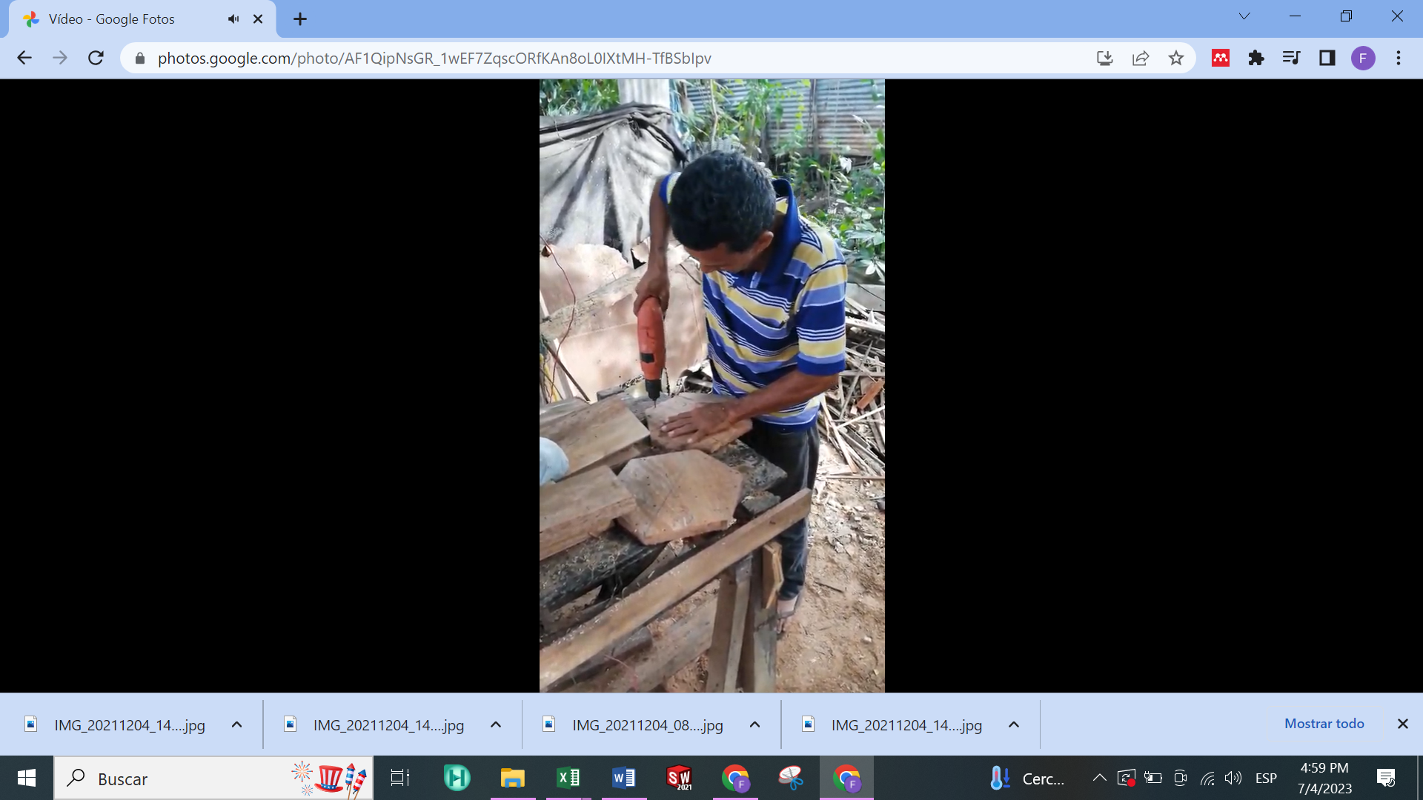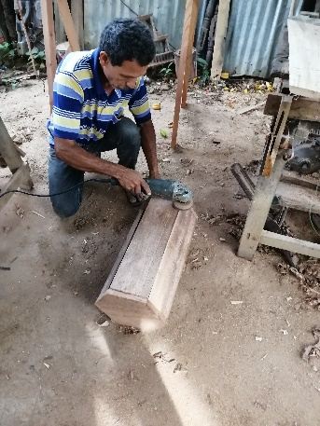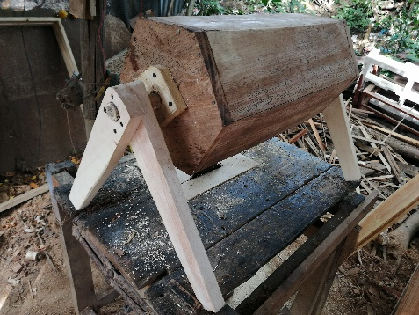

Figure 1: Construction of hexagonal rotary fermenter

Fermentation test in rotary and traditional fermenters

This study evaluated temperature profiles, pH, and Brix degrees during cocoa fermentation in a rotary drum and traditional box fermenters. In the rotary drum, fermentation started at 30°C, peaked at 45°C due to effective aeration and bean rotation, and ended at 35°C, favouring acetic acid bacteria activity. In contrast, the traditional fermenter started below 30°C, peaked at 38.0°C after 144 hours, and maintained temperatures near ambient, sufficient for fermentation but less effective. Brix degrees, initially 17, decreased to 9 in the rotary drum and 12.1 in the traditional fermenter, reflecting carbohydrate consumption by microorganisms. The rotary drum produced cocoa beans with adequate fermentation characteristics, which is consistent with previous studies. The pH in the rotary drum ranged from 4.2 to 4.5, consistent with acid production and consumption during fermentation. At the same time, the traditional fermenter showed an increase in pH to 6.1, attributed to lower temperatures and altered microbial metabolism. Table 3 shows the average temperatures, pH, and Brix degrees during fermentation. An ANOVA test shows that at a significance level of 0.05, temperatures, pH, and Brix degrees are not significantly different considering the type of fermenter used. These results are desirable because, although the fermentation process is technological, it does not affect the quality of the beans at the end of fermentation, which is desirable from the point of view of the final quality of the fermented cocoa.

Table 3: Average values for fermentations using box and drum fermenters

|  |  |  |  |  |  |  |
| --- | --- | --- | --- | --- | --- | --- |
| Time (h) | Box | Drum  Temperature (°C) | pH  Box | Drum | Brix degrees  Box | Drum |
| 0 | 28.0±0.01 | 30.0±0.00 | 4.7±0.01 | 4.2±0.03 | 16.6±0.00 | 17.1±0.01 |
| 24 | 33.0±0.01 | 35.0±0.00 | 3.9±0.00 | 3.8±0.01 | 13.0±0.00 | 17.0±0.00 |
| 48 | 36.5±0.01 | 45.0±0.00 | 4.5±0.01 | 4.8±0.03 | 12.5±0.00 | 14.9±0.07 |
| 72 | 38.0±0.00 | 44.0±0.00 | 4.2±0.01 | 4.2±0.03 | 11.5±0.00 | 13.0±0.05 |
| 96 | 36.0±0.00 | 37.0±0.00 | 3.9±0.02 | 4.2±0.01 | 12.0±0.00 | 13.0±0.00 |
| 120 | 37.5±0.00 | 36.0±0.00 | 5.4±0.01 | 4.5±0.02 | 10.0±0.00 | 9.0±0.00 |
| 144 | 38.0±0.00 | ---- | 6.1±0.01 | ---- | 12.1±0.00 | ---- |

To illustrate what happened during the fermentation of the cocoa beans, Figure 2 shows the grain inside the two fermenters. At the beginning of fermentation, the cocoa beans were smooth, free of contaminants, and had a healthy appearance with a creamy colour. As fermentation progressed, the beans darkened to light or dark brown, became rough in texture, and showed significant mucilage loss, a natural result of the process. In the end, the beans were free of molds or insects, with an easier-to-cut texture and clear fermentation characteristics (Simo-Tagne et al., 2022).

Cutting tests conducted every 24 hours showed that beans in the rotary fermenter initially had a smooth, uniform interior with a purple colour, a live embryo, and a fruity aroma. As fermentation progressed, the beans turned brown, indicating successful biochemical reactions, and after 120 hours, the embryo died, resulting in well-fermented beans with a rough texture and acetic fermentation aroma. In the traditional fermenter, the beans started with a smooth, dark purple interior and a skin that was difficult to peel (Utrilla-Vázquez et al., 2020). Over time, they lightened to a brownish hue but lacked key fermentation characteristics after 120 hours, requiring an additional 24 hours to complete. At 144 hours, the beans had a porous interior, acetic aromas, and no impurities. This is shown in Figure 3.

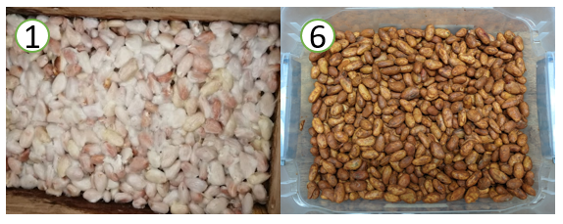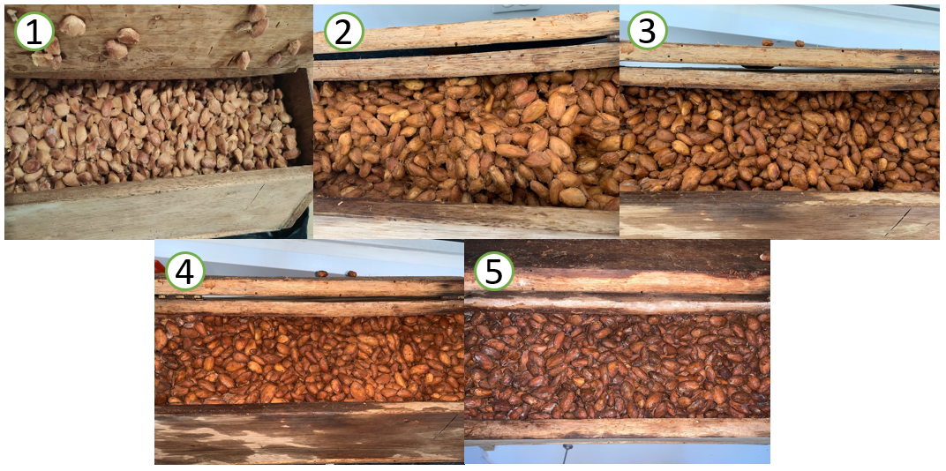

1. (b)

Figure 2 External sensory characteristics inside rotary fermenter (a) and box fermenter (b)

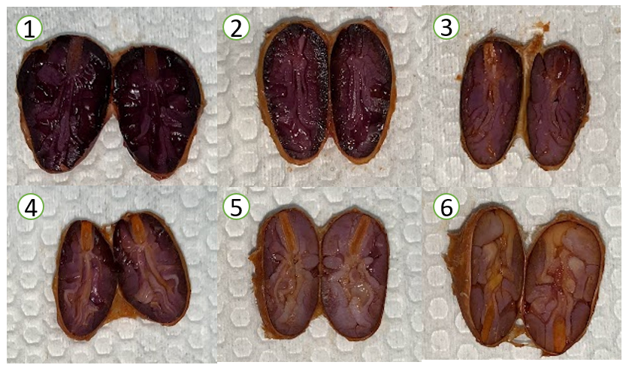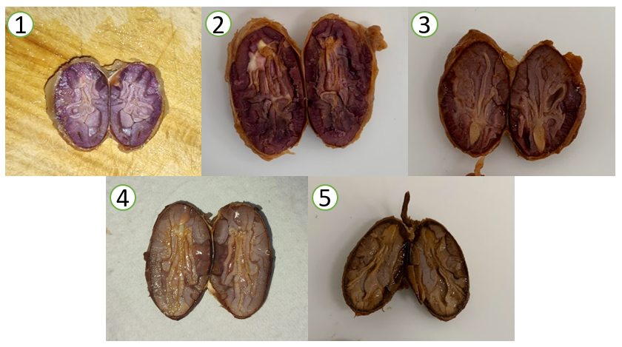

1. (b)

Figure 3: Internal sensory characteristics inside rotary fermenter (a) and box fermenter (b)

* + 1. Cocoa dryer design, construction, and test.

Knowledge was exchanged with cocoa producers, who emphasized the importance of the sensory part when explaining the reality of the process of obtaining cocoa as a raw material for chocolate (Faborode et al., 1995). This exchange of empirical and technical knowledge led to a reassessment of dryer design. Thus, a greenhouse dryer for fermented cocoa beans was designed using Autodesk Inventors software and built by a carpenter using white wood (*Anacardium excelsum*) and polypropylene (Puello-Méndez et al., 2017). It was considered information related to drying flux and speed. This step is aimed at removing moisture but also promoting a mass transfer of volatile and non-volatile substances present in the wood, which are transferred to the cocoa during drying. At this stage, the company Lusotec, a partner in the project, provided valuable information for the calculation of the energy consumption and the sizing of the dryer for the project, as well as the loan of solar panels to evaluate their use for the potential use of a solar energy system. Figure 4 shows the greenhouse drying process.

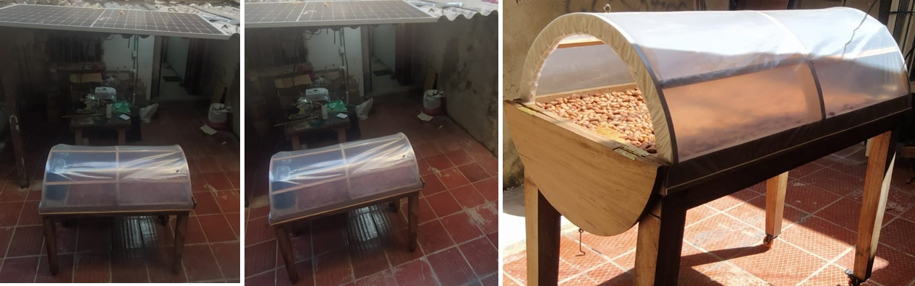

Figure 4: Designed greenhouse dryer connected to a solar panel and two electrical fans.

The drying process is carried out in less time than the process in the shade. It is recommended that the process be carried out at the maximum temperature and speed of the fans; the nominal power of 5.01 kWh/day was taken, requiring four solar panels and five batteries, representing a high investment for local cocoa producers. This dryer provides a more hygienic drying process compared to the traditional open-air process, where there is a possibility of contamination of the beans with insects, wind, and soil dirt, as well as animal feces. The energy consumption of the drying process is influenced by the convection generated by the fans (kinetic energy) and the thermal energy generated by their resistances. It should be emphasized that the lowest energy consumption was obtained in tests with maximum temperature and speed in the sun, with a consumption of 1,789 J in the shade. In contrast, those in the shade generated a higher consumption of 29,501 J. Configurations at the lowest temperature is not recommended, since drying takes up to 20 times longer in the shade than in configurations at the highest temperature. The most noticeable change in the process is the drying time, which went from a range of 4 to 7 days in traditional solar drying to less than 22 hours of drying to reach the expected moisture in the bean (7%); the drying air temperature was an average of 67.64°C. Further tests should be carried out to determine the recommended air temperature to obtain cocoa beans with the expected quality, not only at the physicochemical level but also at the sensory and microbiological levels.

* 1. Conclusions

Combining engineering with the empirical knowledge of cocoa producers can help develop standardized technologies tailored to low-productivity regions such as Montes de María, Colombia. The study showed that a technologized fermentation and drying process is feasible, with the rotary drum reducing fermentation time by 22 hours compared to traditional methods while maintaining similar quality parameters. The pulp and shell showed nutritional potential but required drying due to high moisture content. An engineered dryer halved the drying time but at a high cost, suggesting further optimization, such as the selective use of fans. Microbiological and physicochemical analyses are recommended to establish quality parameters and improve cocoa commercialization, as well as a total carbon analysis and an economic and environmental evaluation.

Acknowledgments

The authors would like to thank the Universidad de Cartagena, especially the Vice-Rectorate of Research, for its financial support of this work through the project entitled: “Implementation of solar energy in the post-harvest of cocoa (*Theobroma cocoa* *L*.) in the Department of Bolivar”, which was approved by Commitment Act No. 159 of 2019, and developed by Professors and a student members of the research group Nanomaterials and Computer Aided Process Engineering – NIPAC, of the Chemical Engineering Program, at the College of Engineering.

References

AOAC. (1998). *Oficial Metodos of analysis AOAC Internacional* (A. International (ed.); 16th Editi). http://www.aoac.org

Faborode, M. O., Favier, J. F., & Ajayi, O. A. (1995). On the effects of forced air drying on cocoa quality. *Journal of Food Engineering*, *25*(4), 455–472. https://doi.org/10.1016/0260-8774(94)00018-5

Herrera-Barros, A., Puello-Mendez, J., Pasqualino, J. C., & Lambis-Miranda, H. A. (2022). Agro-Industrial Waste from Cocoa Pod Husk (Theobroma cacao L.), as a Potential Raw Material for Preparation of Cellulose Nanocrystals. *Chemical Engineering Transactions*, *92*(April), 205–210. https://doi.org/10.3303/CET2292035

Puello-Méndez, J., Meza-Castellar, P., Cortés, L., Bossa, L., Sanjuan, E., Lambis-Miranda, H., & Villamizar, L. (2017). Comparative Study of Solar Drying of Cocoa Beans: Two Methods Used in Colombian Rural Areas. *Chemical Engineering Transactions*, *57*, 1711–1717. https://doi.org/DOI: 10.3303/CET1757286

Sahin, S., & Sumnu, S. G. (2007). *Physical Properties of Foods* (1st ed.). Springer New York, NY. https://doi.org/https://doi.org/10.1007/0-387-30808-3

Simo-Tagne, M., Tamkam Etala, H. D., Tagne Tagne, A., Ndukwu, M. C., & El Marouani, M. (2022). Energy, environmental and economic analyses of an indirect cocoa bean solar dryer: A comparison between natural and forced convections. *Renewable Energy*, *187*, 1154–1172. https://doi.org/10.1016/j.renene.2022.02.015

Tosto, A., Morales, A., Rahn, E., Evers, J. B., Zuidema, P. A., & Anten, N. P. R. (2023). Simulating cocoa production: A review of modelling approaches and gaps. *Agricultural Systems*, *206*, 103614. https://doi.org/10.1016/J.AGSY.2023.103614

Utrilla-Vázquez, M., Rodríguez-Campos, J., Avendaño-Arazate, C. H., Gschaedler, A., & Lugo-Cervantes, E. (2020). Analysis of volatile compounds of five varieties of Maya cocoa during fermentation and drying processes by Venn diagram and PCA. *Food Research International*, *129*(November 2019), 108834. https://doi.org/10.1016/j.foodres.2019.108834

Veira, J., Cuaycuan, E., & Espana, N. (2019). Automatic fermentation and drying cocoa process. *4th IEEE Colombian Conference on Automatic Control: Automatic Control as Key Support of Industrial Productivity, CCAC 2019 - Proceedings*, 1–6. https://doi.org/10.1109/CCAC.2019.8921378